**Forcasting with Excel**

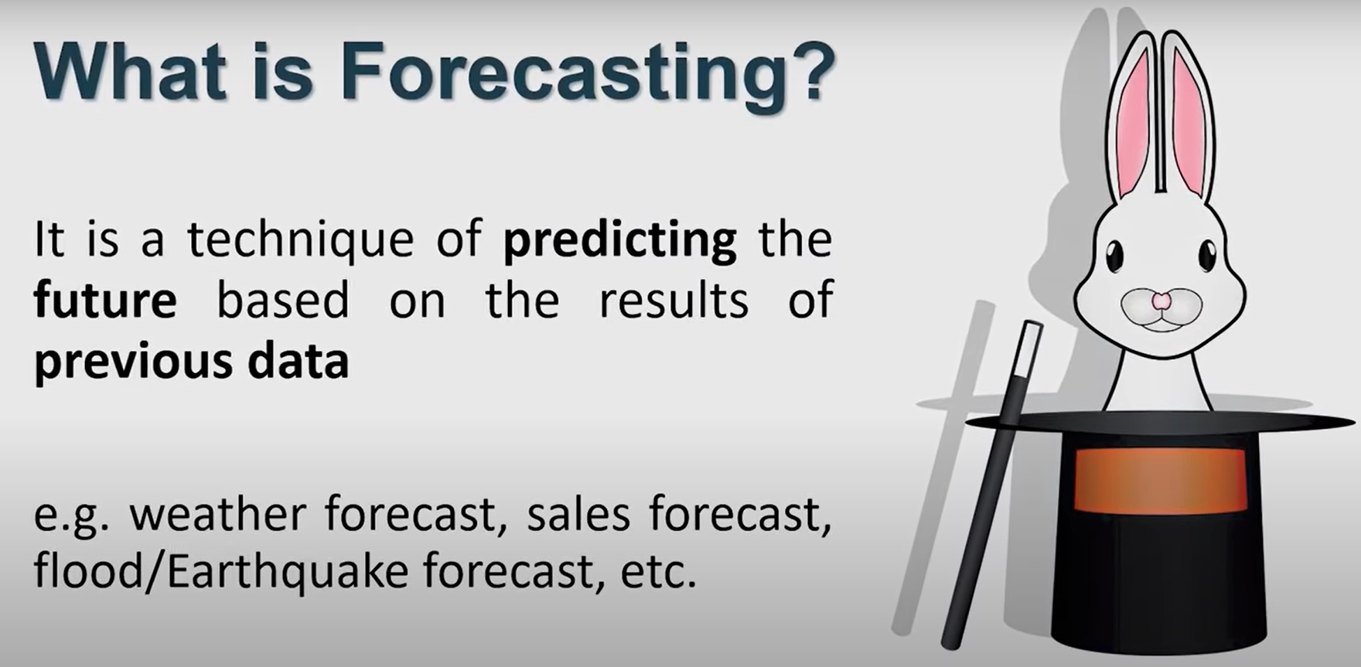

**3 methods:**

**1.Using formula**

**2.Using Graph**

**3.Using Forecast sheet**

**1.Forcasting Formula:**

1.Choose simple Forcast option only

2.Choose x known value where I have to predict y

3.Choose y’s all recorded value

4.Choose x all recorded values without x which I used to predict

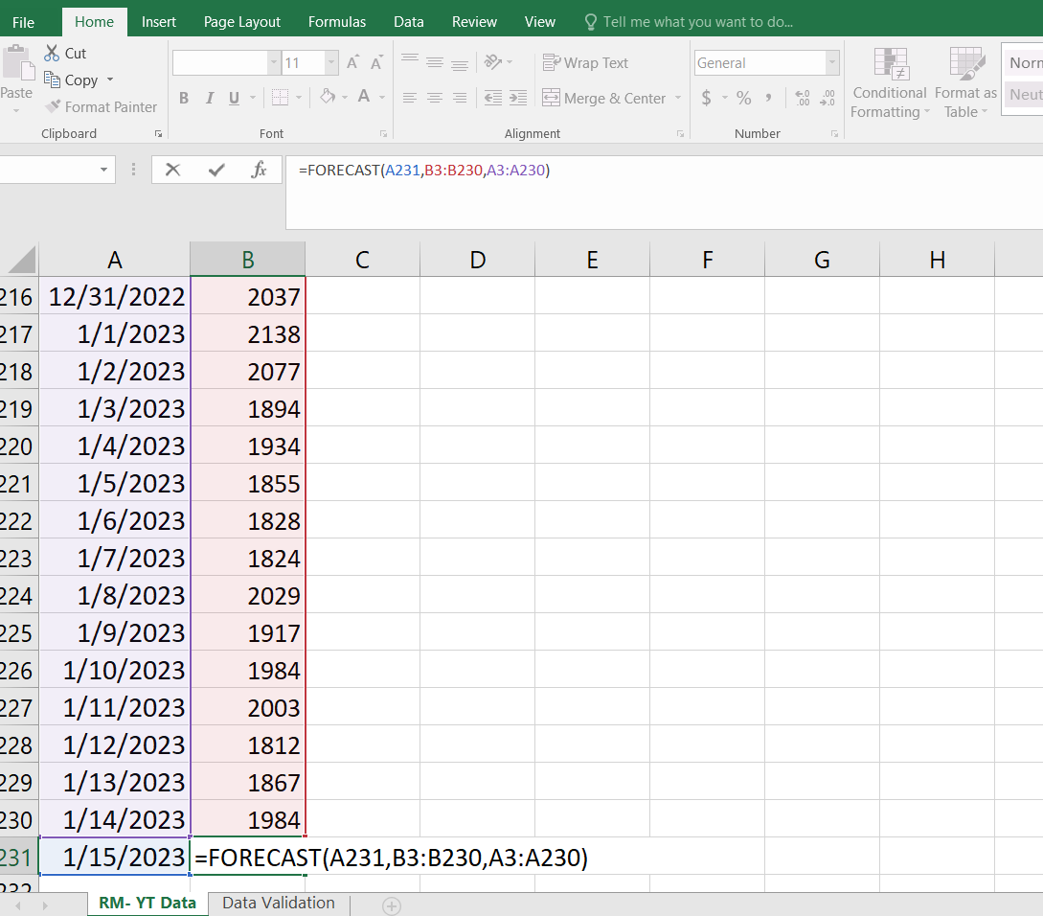

Pressing enter and predicted:

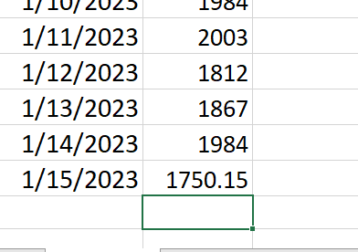

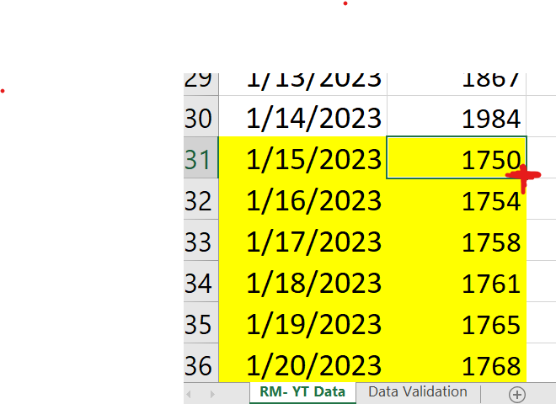

**We can predict next cells just click the plus right-down side**

To delete cells and all changes

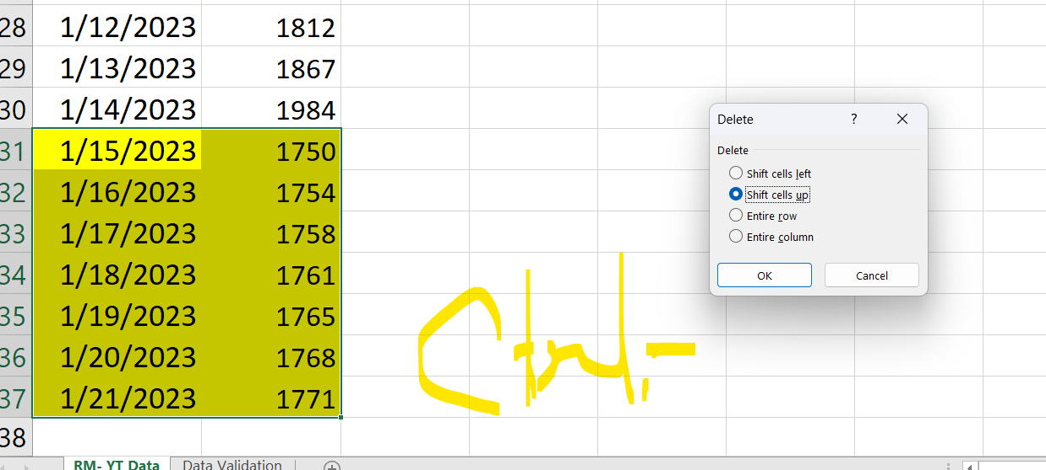

**2.Forecasting with Graph-Trendline**

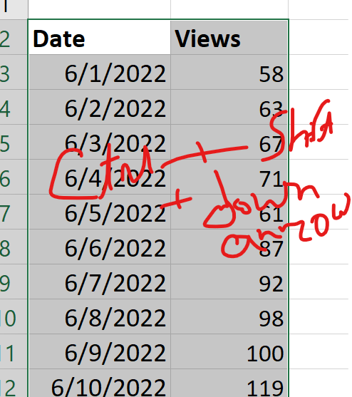

**Ctrl+Shift+down key for selection all coloums values**

**Go to insert and line chart :**

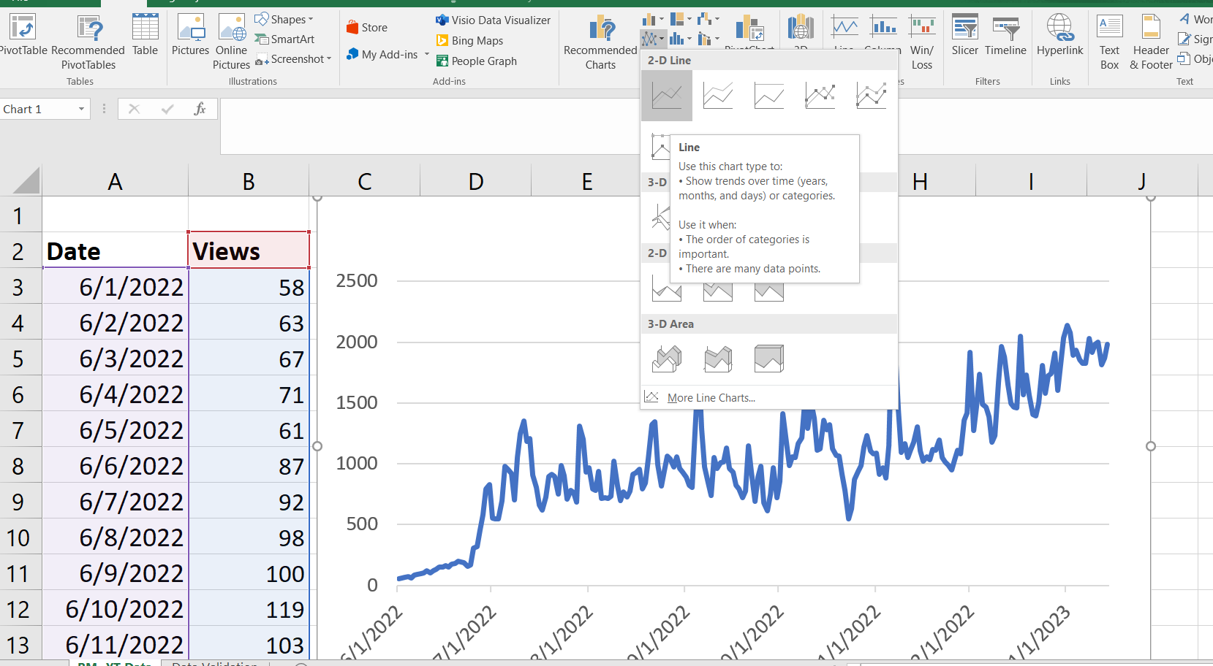

**Using tradlines which use models like linear regression**

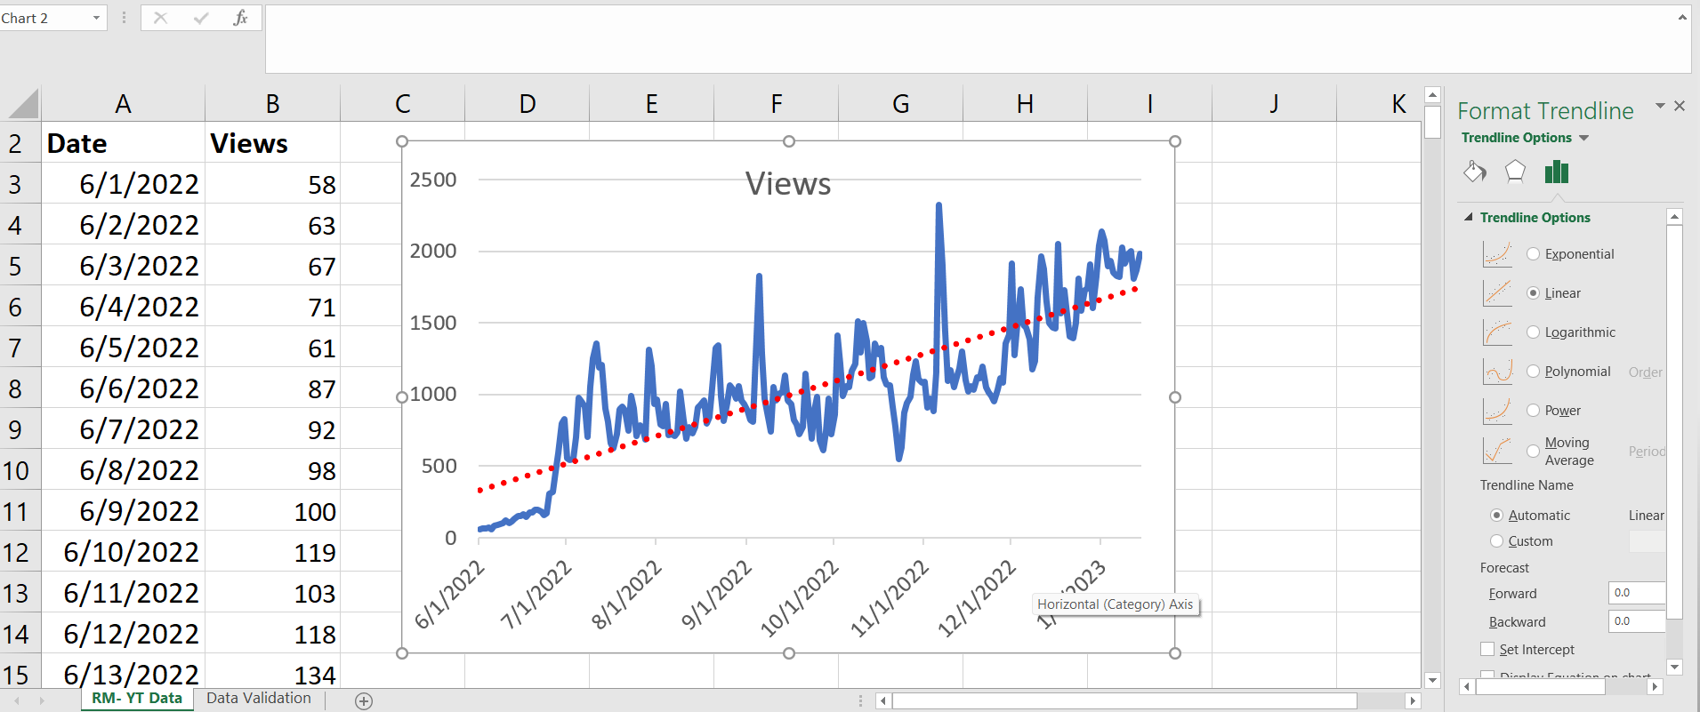

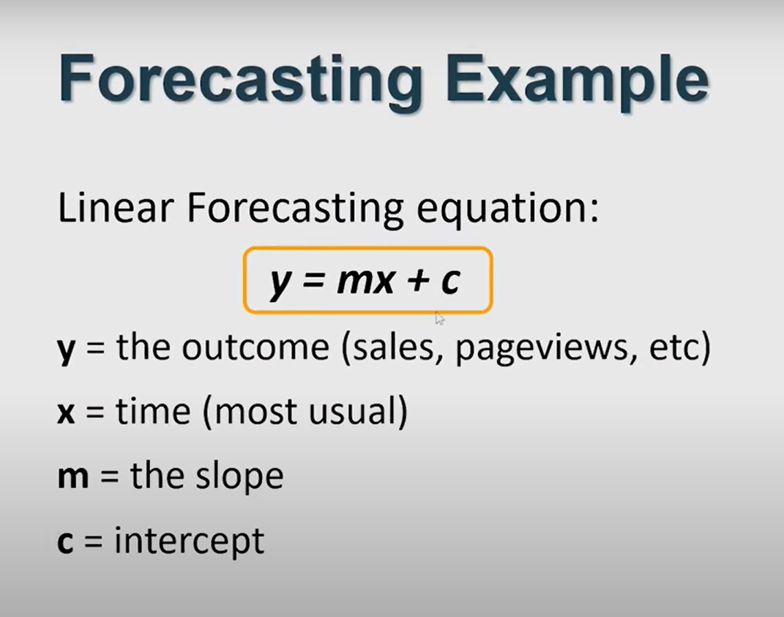

What model should use:

Depends on higher R squar value

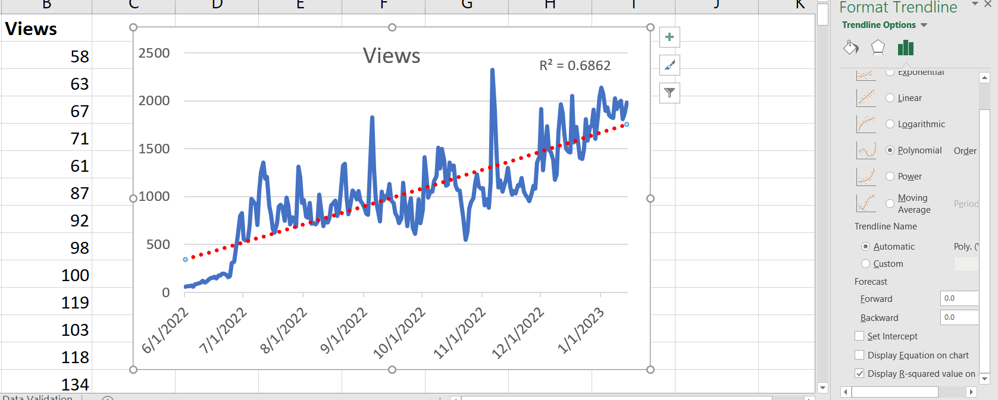

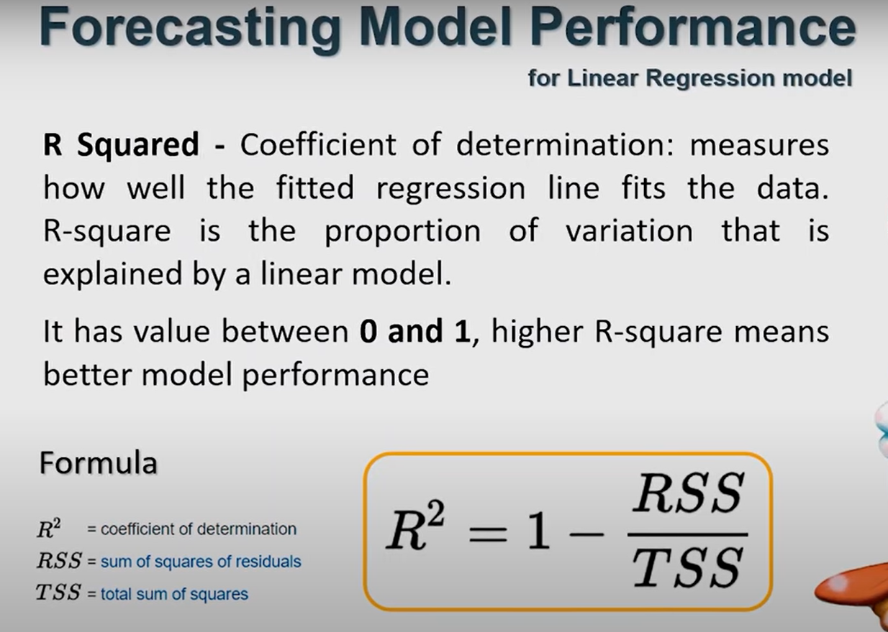

14 days forecast:

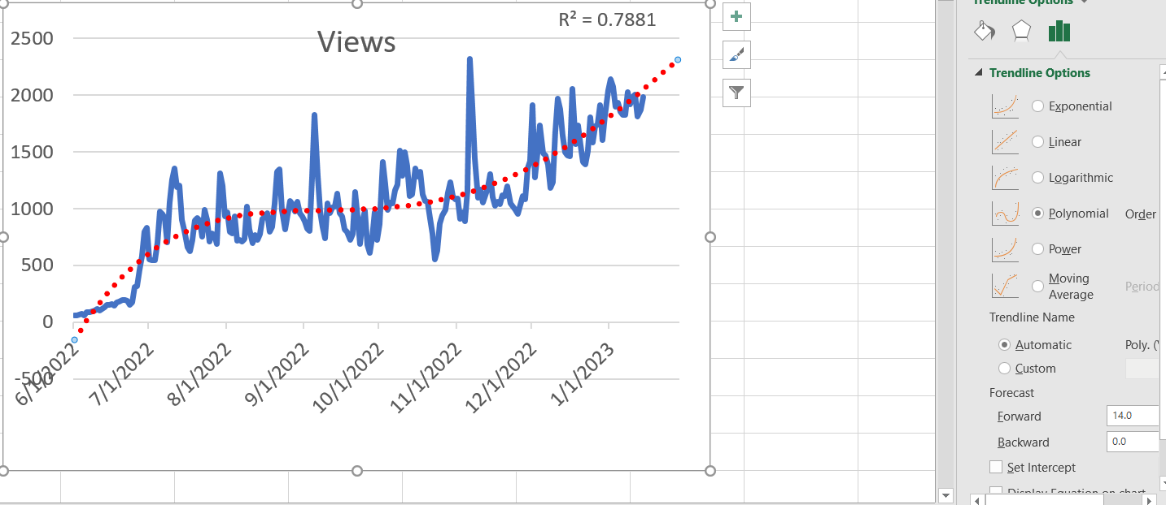

Which is similar to real values

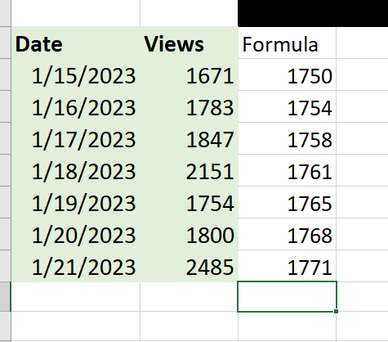

**Note: Inbuilt forecasting is better than the formula for this scenario. BecauseI didn’t choose only linear I choose polynomial because its R2 value is better.**

**3.Forecast Sheet**

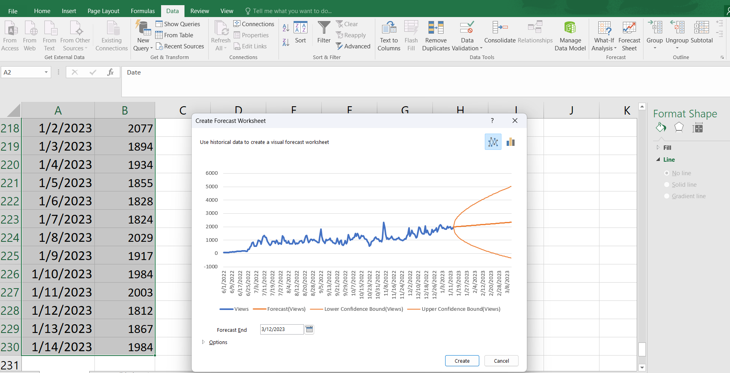

**Select column then go data tab🡪forecast sheet**

**After creating for 7 days forecast:**

